Work Management System

Software Design Specification

Version 1.0

# **Introduction**

## **Overview**

This is the application that allows the leader to members assigned based on the phone number. Easy job assignment, arrange to work smart and timely reminders.

# **Functional Requirements**

## **Feature/Component #1: Enter Phone Number**

### Users Interfaces

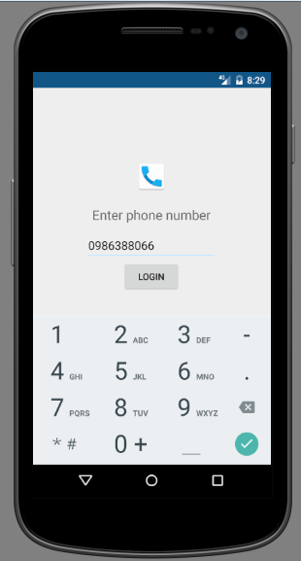

### Functional Requirements

|  |  |  |  |
| --- | --- | --- | --- |
| **Response** | **Action** | **Description** | **Item** |
| N/A | N/A | User must enter phone number. | **Phone Number editText** |
| Received sms verify code. | Send phone number to server. | Waiting to response from server. | **LogIn button** |
| N/A | N/A | User use to enter phone number to Phone Number editText. | **Keyboard** |

**How to work:**

-Enter Phone Number:

+User must enter themself phone number into Phone Number editText with Keyboard.

+ Click LogIn button.

+Program will Call RESTful API with parameter is phone number

+Response JSON have Userid if phone number exists on server.

-Verify Phone Number:

+Server will send verify code via SMS.

+If program do not automatic generate verify code User must enter into Verify Code Sreen.

+Program will call RESTful API with Userid and Verify code.

+If success Server will response JSON contain: status, userid, token. Program will automatic change to Loading Data Screen.

+If failed program will change to Connection Error Screen.

## **Feature/Component #2: Loading Data Screen**

### Users Interfaces

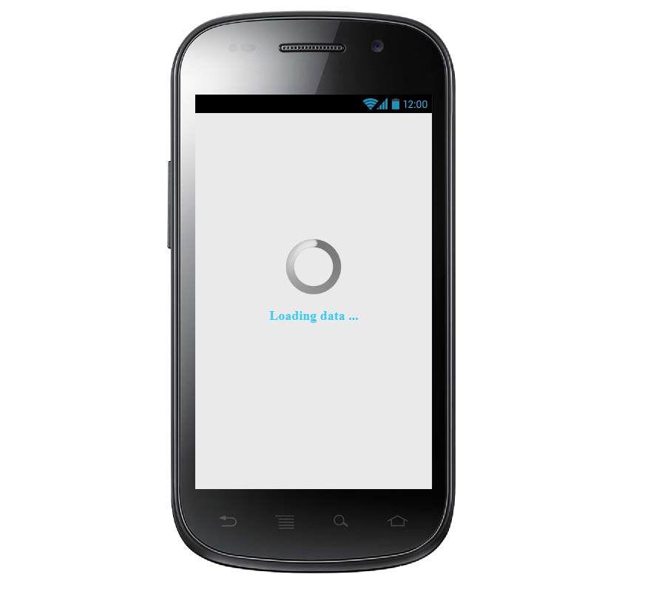*Image1: Loading data from server*

### Functional Requirements

|  |  |  |  |
| --- | --- | --- | --- |
| **Response** | **Action** | **Description** | **Item** |
| N/A | N/A | Loading Screen has 1 Spinner, 1 textview:   * Spinner loading data * Textview “Loading data” | **Loading Screen** |
| Load data to Work List Screen | Load data from the server | Waiting to load data from the server | **Loading data** |

**How to work:**

-Get Data Task:

+Get success UserID and Token.

+Call RESTful API with parameter are UserID and Token.

+Server will response result JSON (view JSON structure in SDS - Manager Software.doc)

+Process data result

-Start screen:

+Automatic run Get Data Task

-Storage data:

+Class: Task (int TaskId, string TaskName, string Descript, date Startdate, data Finishdate)

+Storage in ArrayList<Task>

## **Feature/Component #3: Connection Error Screen**

### 2.2.1 Users Interfaces

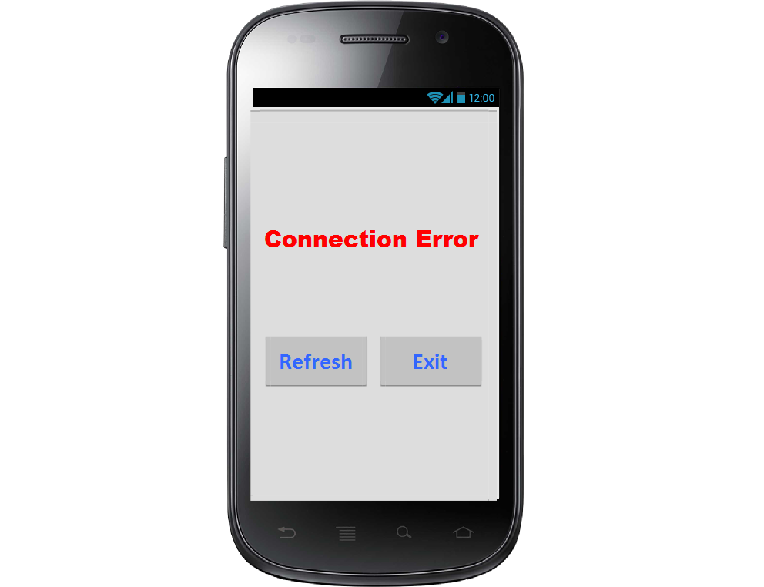

*Image1: Connection error*

### Functional Requirements

|  |  |  |  |
| --- | --- | --- | --- |
| **Response** | **Action** | **Description** | **Item** |
| N/A | N/A | Loading Screen has 1 Textview, 2 button:   * Textview “Connection Error” * Button “Refresh” * Button “Exit” | **Connection error screen** |
| Display loading data screen | Load data from server | Reload data from server | **Refresh button** |
| Close application | Close application | Close application | **Exit button** |

**How to work:**

**Refresh button:** Get Data Task again

**Exit button:**

Close application: call finish() method

## **Feature/Component #4: Not Found Screen**

### User Interfaces

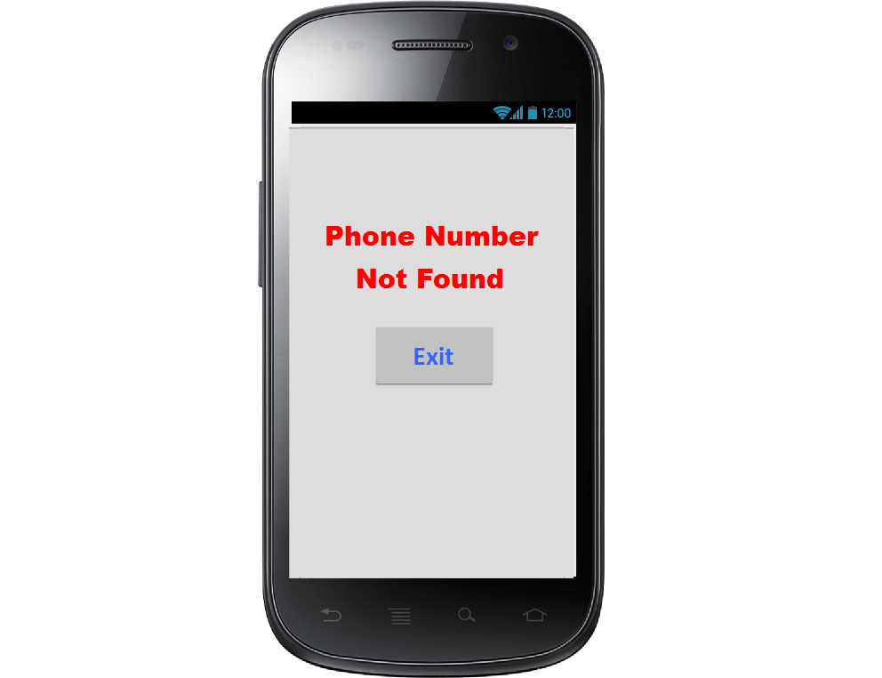

*Image1: Not found phone number*

### Functional Requirements

|  |  |  |  |
| --- | --- | --- | --- |
| **Response** | **Action** | **Description** | **Item** |
| N/A | N/A | Loading Screen has 1 Textview, 1 button:   * Textview “Phone Number Not Found” * Button “Exit” | **Not found screen** |
| Close application | Close application | Close application | **Exit button** |

**How to work:**

**Exit button:** Close application: call finish() method

**Trigger:** Phone number not exist in system (**status** is **false** by JSON result)

## **Feature/Component #5: Work List Screen**

### User Interfaces

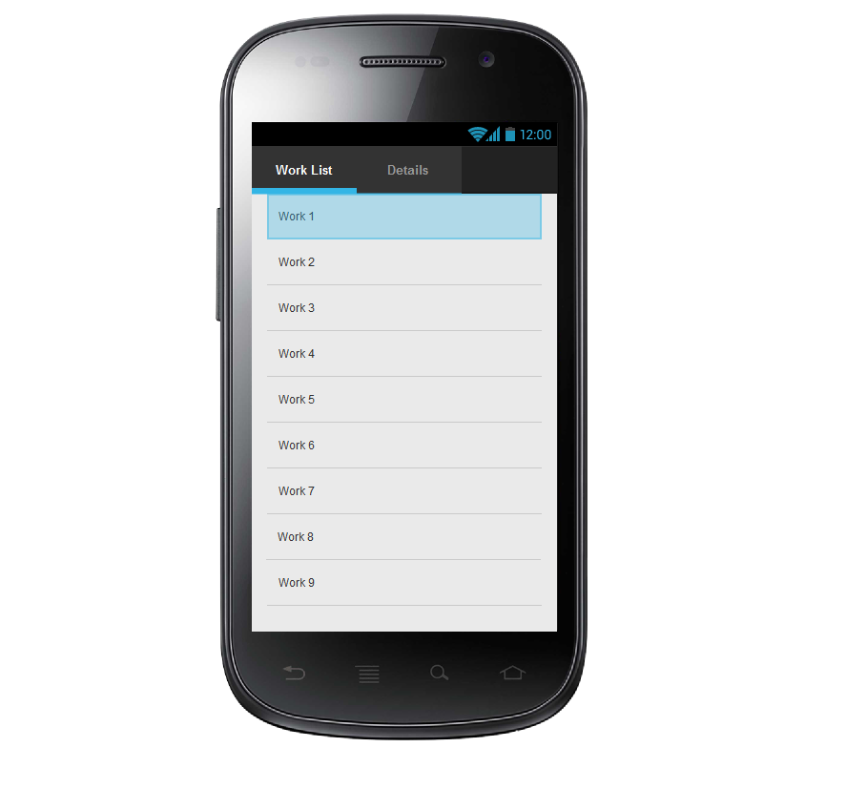

*Image2: Work List*

### Functional Requirements

|  |  |  |  |
| --- | --- | --- | --- |
| **Response** | **Action** | **Description** | **Item** |
| N/A | N/A | Work List Screen has 2 Tabs, 1 Listview to display the list of work:   * Work List * Detail * stview work | **Work List Screen** |
| Work list is showed | Tap on Work List | Show the work list loading from the server | **Work List Tab** |
| Disable | Disable | Tab disabled when not at work | **Detail Tab** |

**How to work:**

-Default Detail tab is disabled

-Select task in list:

+Check task id in memory

+Load task information

+Show data Textview in Detail tab

+Enable Detail tab

+Translate to Detail tab

## **Feature/Component #6: Detail Screen**

### User Interfaces

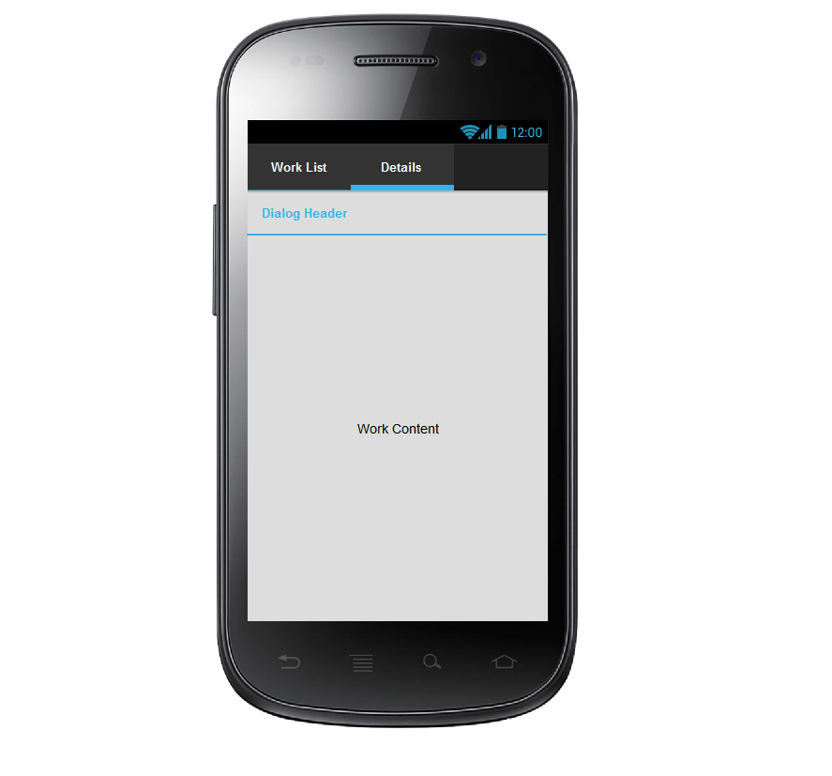

*Image3: Details*

### Functional Requirements

|  |  |  |  |
| --- | --- | --- | --- |
| **Response** | **Action** | **Description** | **Item** |
| N/A | N/A | Detail Screen has 2 Tabs and 1 textbox title and 1 text content work   * Tab Work list * Tab detail * Textbox title work * Text content work | **Detail on Screen** |
| Work detail is showed | Tap on detail | Show detail work when press on tab Detail include:   * Title * Description work | **Tab detail** |
| Title is showed |  | Shows Title of work | **Title** |
| List items are displayed |  | Description detail work | **Work content** |

How to work:

-Listen hardware Back button action:

+Return to Work List tab

+Disable Detail tab

***---------- End of Document ----------***